Chapter 12 Assessment
Names and Terms
- Communism
- Sacco and Vanzetti
- Calvin Coolidge
- John L. Lewis
- Warren G. Harding
- Fordney-McCumber Tariff
- Isolationism
- Quota System
- Teapot Dome Scandal
- Installment Plan

Main Ideas
Section one: (pg. 412 to 418)
- Explain how the Red Scare, the Sacco and Vanzetti case and the rise of the KKK reflected concerns held by many Americans?
- Describe the primary goal of the immigration quota system established in 1921?

Section 2: (pg. 419 to 421)
- What did Harding want to do to return America to “normalcy”?
- Summarize the teapot Dome scandal.

Section 3: (pg. 422 to 427)
- How did changes in technology in the 1920’s influence American life?
- What evidence suggest that the prosperity of the 1920’s was not on firm foundation?

Standardized Test Practice
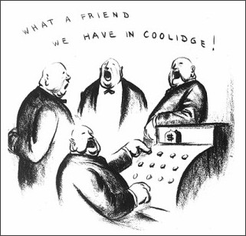
- The cartoon criticizes President Coolidge by suggesting that_________________.
  - Coolidge’s policies benefited wealthy business owners
  - Coolidge was known as “Silent Cal” because he had no economic policy
  - Coolidge provided cash assistance to struggling industries
  - Coolidge has supported the Immigration Act

- After WWI ended, workers in many industries went on strike for wage increases and better working conditions. But in the decade that followed, public support of labor unions declined as did union membership. Which of the following helps to explain this decline in labor union popularity?
f. Wages and working conditions in most industries had already improved before the mid
1920’s
g. Most labor unions actively opposed isolationist policies
h. Most labor unions had large immigration membership
I. Few labor unions would allow unskilled veterans returning from the war to join

- Which of the following beliefs did not result from America’s desire for “normalcy” after WWI?
  - Isolationism
  - Conservationism
  - Nativism
  - Anarchism

