Political Parties Activity Booklet

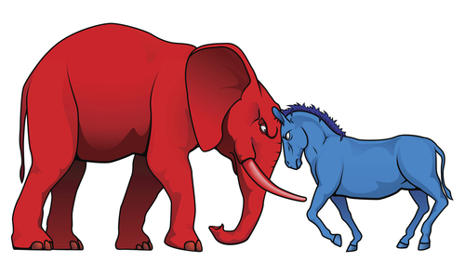

Robert Murray
Mr. Murray
4th Hour
3-18-2016

