Marketing Ch. 13 Graphic Organizer Name:_________________________

Hour:______

Outline of the Preliminary Activities Associated with the Sales Process:

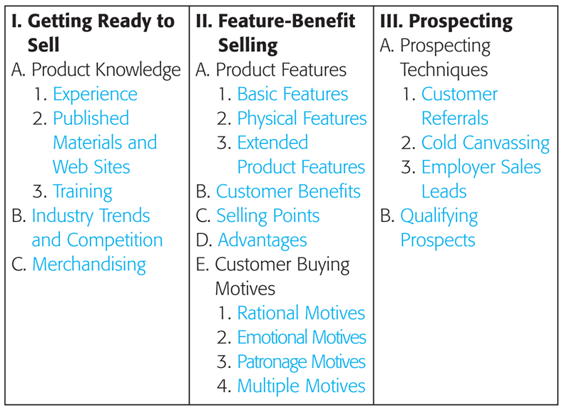

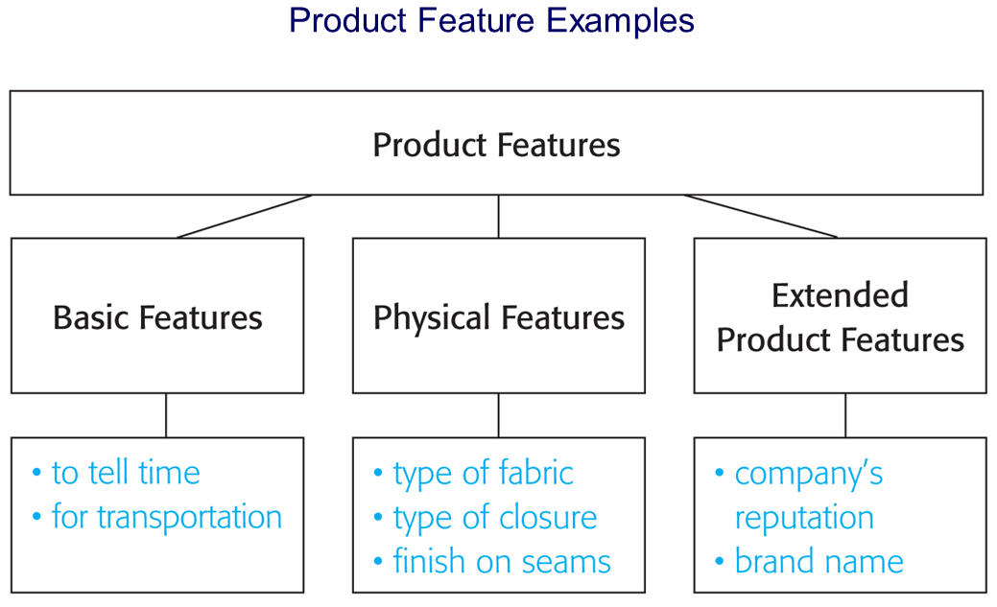

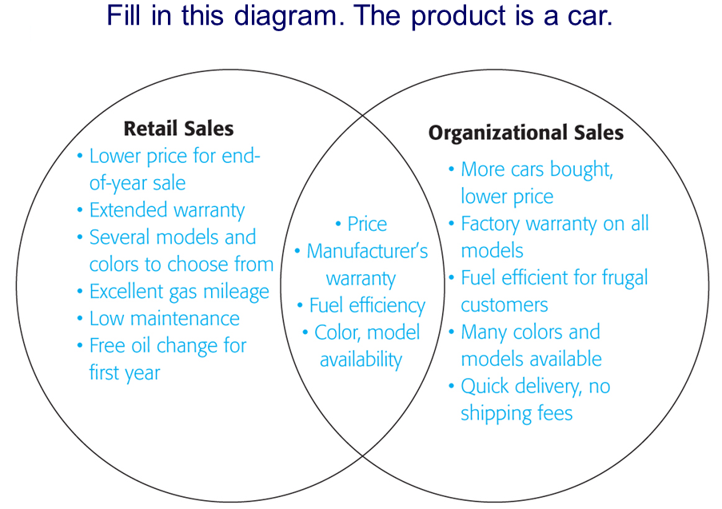

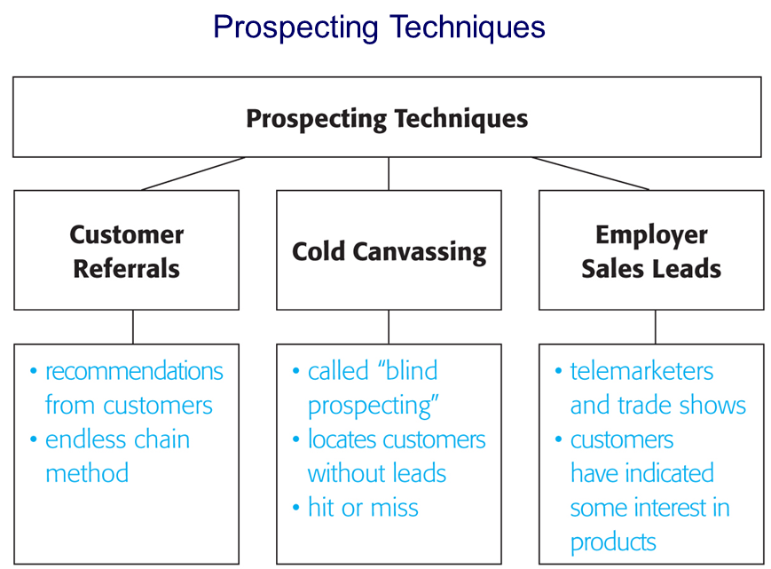

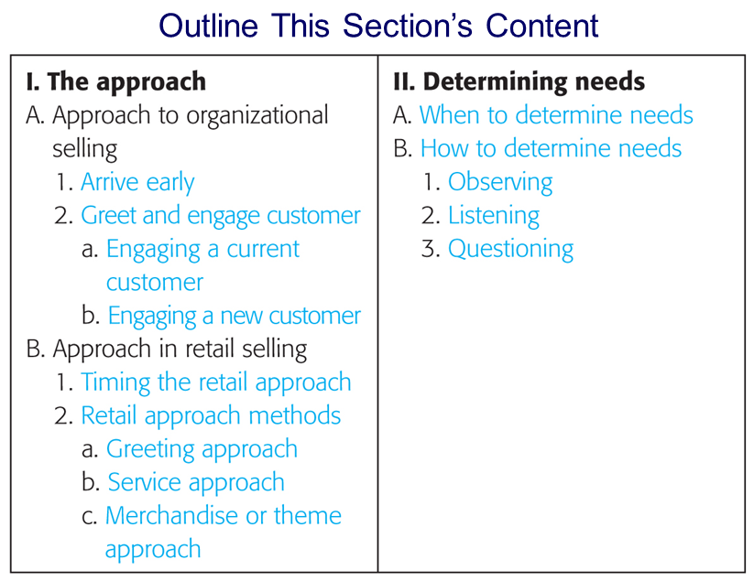

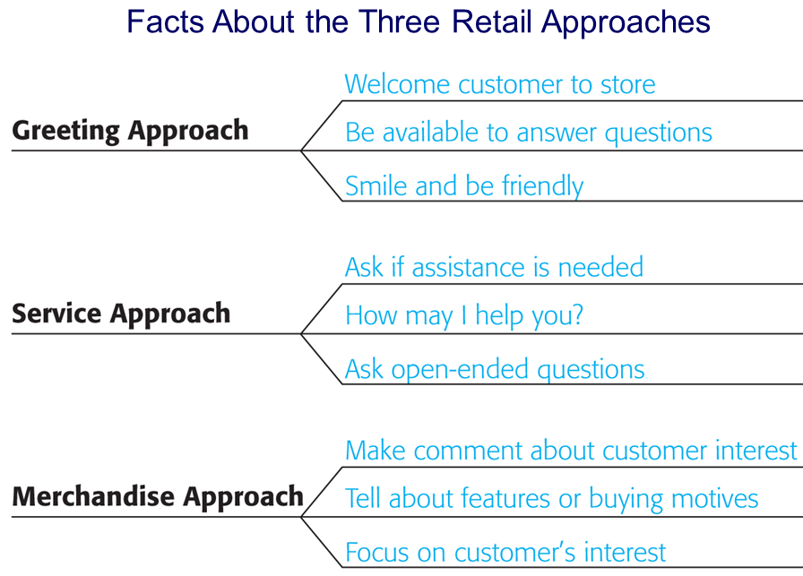

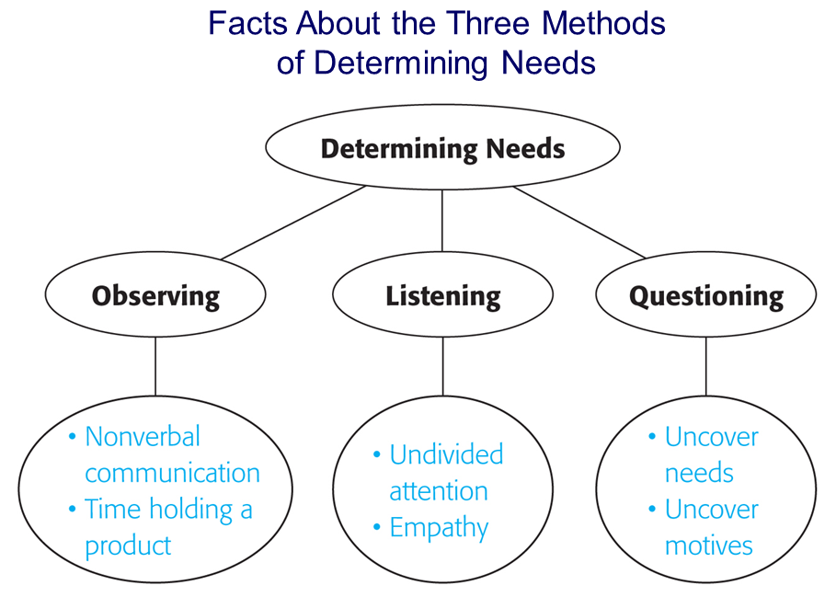

Questions to Ask and Questions Not to Ask When the Customer is Shopping for a Microwave Oven

