Marketing Ch. 12 Graphic Organizer Name:_________________________

Hour:______

Detalis on Selling and the Marketing Concept and Sales Management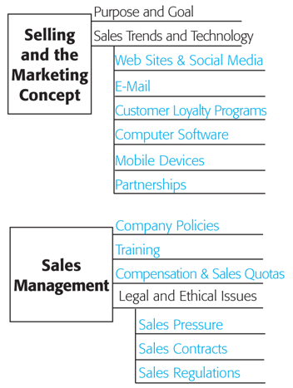

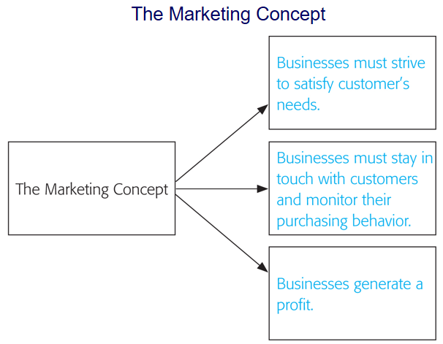

Four Concepts of Sales Management and Examples

