Dear future AP Calculus student,

There are certain math skills that have been taught to you over the previous years that are necessary to be successful in calculus. If you do not have these skills, you will consistently struggle to correctly solve problems next year, even though you understand the calculus concepts. It is frustrating for students when they are doing calculus but are tripped up by the algebra. This summer packet is intended to help you brush up on and possibly relearn these topics.

On the following pages are problems from many different, important topics. All problems should be done on a separate sheet of paper, in order, and all necessary work must be shown. Your work will be **due on the first day (half day) of class and will be graded as a quiz.** To make the most of the packet and to start the semester off right, I recommend you spend some quality time with the packet this summer. Do not try to finish it before school is out for the summer – I want the topics fresh in your mind in the fall! Do not attempt to do it all the night before the first day of class – you will find it a daunting task! A few hours of review, off and on, over the summer will provide the best review.

Some other “don’ts” – Don’t rely on your calculator. Thirty-two of the fifty-one questions on the AP exam are calculator inactive. Every problem in the packet is meant to be done without a calculator. I know that this is scary, but you can do it. They are meant to be done with paper and pencil and your brain. Don’t fake your way through this. I have provided the answers for you. I want to see the process you use to get there. If you find yourself needing assistance, please utilize the websites listed below or contact me. In some cases, the websites listed have full instructions on certain techniques. I cannot emphasize enough that prospective AP Calculus students are notoriously weak on these topics, even students who have been very successful in previous math classes.

Websites:

<http://www.khanacademy.org/>

<http://www.purplemath.com/modules/index.htm>

<http://www.mathmistakes.info/>

<http://www.algebrahelp.com/>

<http://www.themathpage.com/>

<http://www.mathtv.com/>

<http://www.analyzemath.com/>

<http://www.mathwords.com/>

<http://www.regentsprep.org/>

**My e-mail:** [vescani@dearbornschools.org](mailto:vescani@dearbornschools.org)

(I check almost daily)

**AP Calculus Summer Packet**

***Instructions:* Where applicable, put your answers in interval notation. Do not solve with a calculator. Do all work on a separate sheet of paper and do the problems in order. SHOW ALL WORK!**

**Topic 1: Operations with fractions**

**Express each as fractions in simplest form.**

1.  2.  3.  4. 
2.  6. 

**Topic 2: Exponents**

**Simplify.**

1.  2.  3.  4.  5. 
2.  7.  8. 

**Topic 3: Equations of Lines**

**Determine the equation of each line.**

1. The line through  and .
2. The line through  and perpendicular to the line .
3. The line through  and the midpoint of the line segment from  to .

**Topic 4: Domain**

**Find the domain of each function.**

1.  2.  3.  4. 

**Topic 5: Inequalities**

**Solve.**

1.  2.  3.  4.  5. 

**Topic 6: Special Factorization**

**Factor completely.**

1.  2.  3. 
2. 

**Topic 7: Solving Quadratic and Polynomial Functions**

**Solve.**

1.  2.  3. 
2.  5. 

**Topic 8: Dividing Polynomials**

1. Divide  by 
2. Solve using the factor theorem (p over q method/ synthetic division): 

**Topic 9: Complex Fractions**

**Simplify.**

1.  2.  3.  4. 

**Topic 10: Solving Rational Equations**

**Solve.**

1.  2. 

3.  4. 

**Topic 11: Composition of functions**

If, find the following:

1.  2.  3.  4. 

**Topic 12: Transforming functions**

**Describe in words what the following would do to** .

1.  2.  3.  4.  5. 

**Topic 13: Right Triangle Trigonometry**

1. If  and  is in Quadrant II, find sin and tan.
2. If  and  is in Quadrant III, find sin and cos.
3. Find .
4. A kite is 100 m above the ground. If there are 200 m of string out, what is the angle between the string and the horizontal? (Assume that the string is perfectly straight)

**Topic 14: Solving Trigonometric Equations**

**Solve each equation on the interval** .

1.  2.  3.  4. 
2. 

**Topic 15: Logarithms**

1. Write  as a single log.
2. Solve .

**Simplify.**

1.  4.  5.  6.  7. 
2.  9.  10.  11. 

**Topic 16: Area and Perimeter**

1. Write an expression for the area of the shaded region.
2. Writean expression for the perimeter of the window below.
3. A water tank has the shape of a cone (like an ice cream cone without the ice cream). The tank is 10 m high and has a radius of 3 m at the top. If the water is 5 m deep, what is the surface area of the top of the water?

**Topic 17: Piecewise Functions**

1. Graph the following (label important points) and evaluate at the given values of x.
$f\left(x\right)=\left\{\begin{aligned}x+5, &x<-2 \\ -2x-1, &x≥-2\end{aligned}\right.$ $f\left(3\right), f\left(-4\right), f(-2)$

$f\left(x\right)=\left\{\begin{aligned}2x+1, &x≥1 \\ \frac{1}{2}x-3, &x<1\end{aligned}\right.$ $f\left(-2\right), f\left(6\right), f\left(1\right)$

$f\left(x\right)=\left\{\begin{aligned}4x-2, &x≥2 \\ -\frac{x}{3}+4, &x<2\end{aligned}\right.$ $f\left(-4\right), f\left(8\right), f\left(2\right)$

$f\left(x\right)=\left\{\begin{aligned}-x+4, x≤0 \\ \frac{2}{3}x-1, &0<x≤5 \\ 2, x>5\end{aligned}\right.$ $f\left(-2\right), f\left(0\right), f\left(5\right)$

$f\left(x\right)=\left\{\begin{aligned}-4, x≤-2 \\ x-2, -2<x<2 \\ -2x+4, x≥2\end{aligned}\right.$ $f\left(-3\right), f\left(-2\right), f\left(2\right)$

$f\left(x\right)=\left\{\begin{aligned}\left|x-3\right|, x<1 \\ {\left(x-1\right)}^{4}, x=1 \\ \sqrt{4x}, x>1\end{aligned}\right.$ $f\left(0\right), f\left(1\right), f\left(4\right)$

2. Write equations for the piecewise functions whose graphs are shown. Assume the units are 1 for every tic mark.





**From your textbook:**

**Work on page 56 # 1-11, 21-24, 31, 33, 35, 37, 55-59, 63, 65**

**AP Calculus Summer Packet – Solutions**

**Topic 1:** 1. 1 2.  3.  4.  5. 100 6. 

**Topic 2:**  1. 8 2. 1 3.  4. 16 5.  6. 

7.  8. 

**Topic 3:** 1.  2.  3. 

**Topic 4:** 1.  2.  3.  4. 

**Topic 5:** 1.  2.  3.  4.  5. 

**Topic 6:** 1.  2. 

3.  4. 

**Topic 7:** 1.  2.  3.  4.  5. 

**Topic 8:** 1.  2. 

**Topic 9:** 1.  2.  3.  4. 

**Topic 10:** 1.  2.  3.  4. No solution  is extraneous

**Topic 11:** 1. 9 2. 3 3.  4. 

**Topic 12:** 1. Shift down 4 2. Shift right 4 3. Reflection over the x axis, shift left 4

4.Vertical stretch by 5, shift up 4 5. Horizontal shrink by 

**Topic 13:** 1.  2.  3. 1 4. 

**Topic 14:** 1.  2.  3. 

4.  5. 

**Topic 15:**  1.  2.  3. 25 4.  5. 0 6. 

7.  8. 49 9. 1 10. 6 11. 2

**Topic 16:** 1.  2.  3.  m2

**Topic 17**

1. 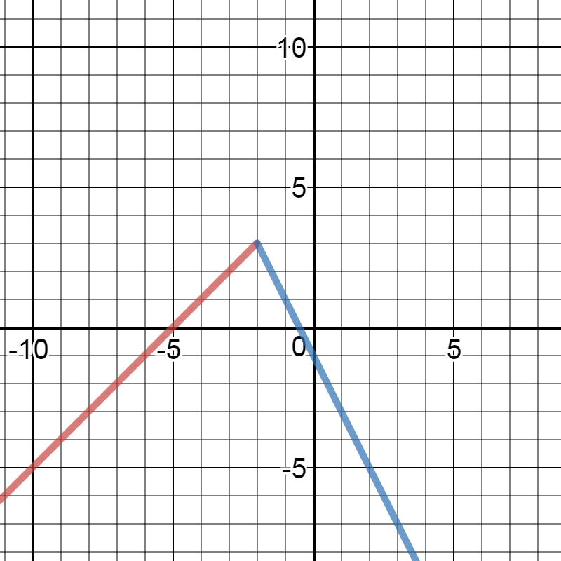 **b. 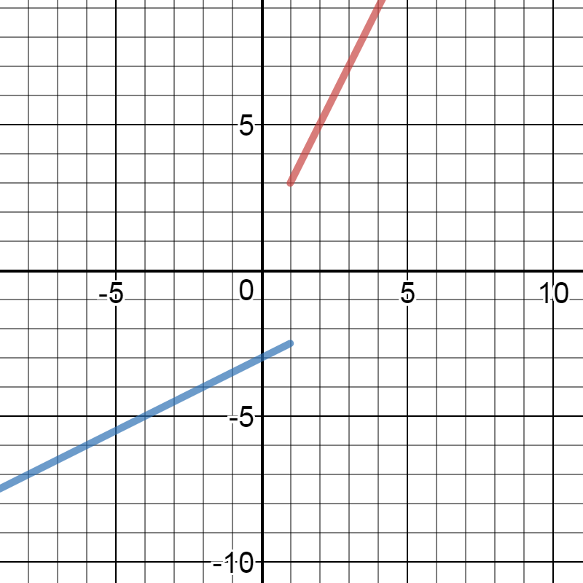 c.** 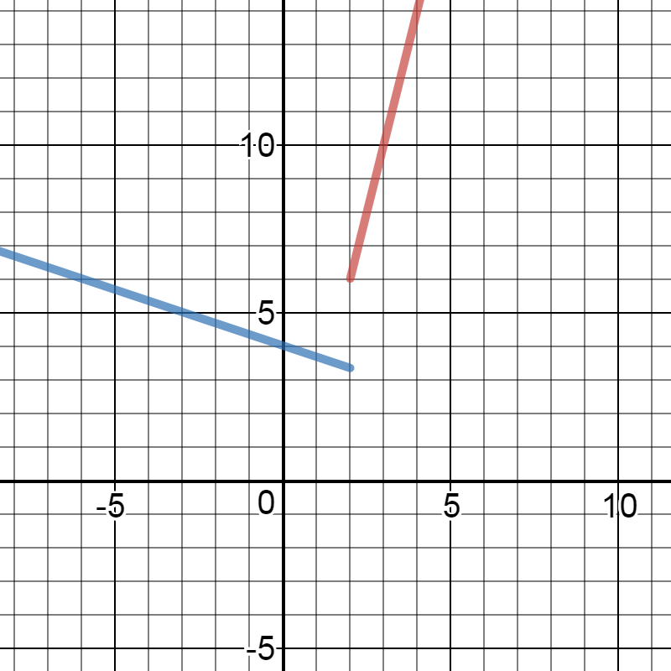

**d. 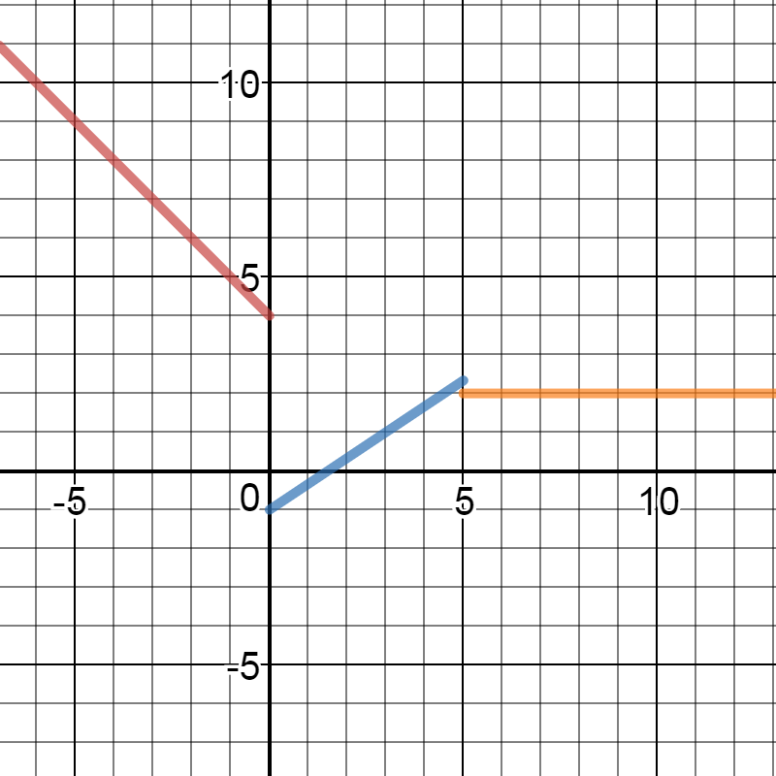 e. 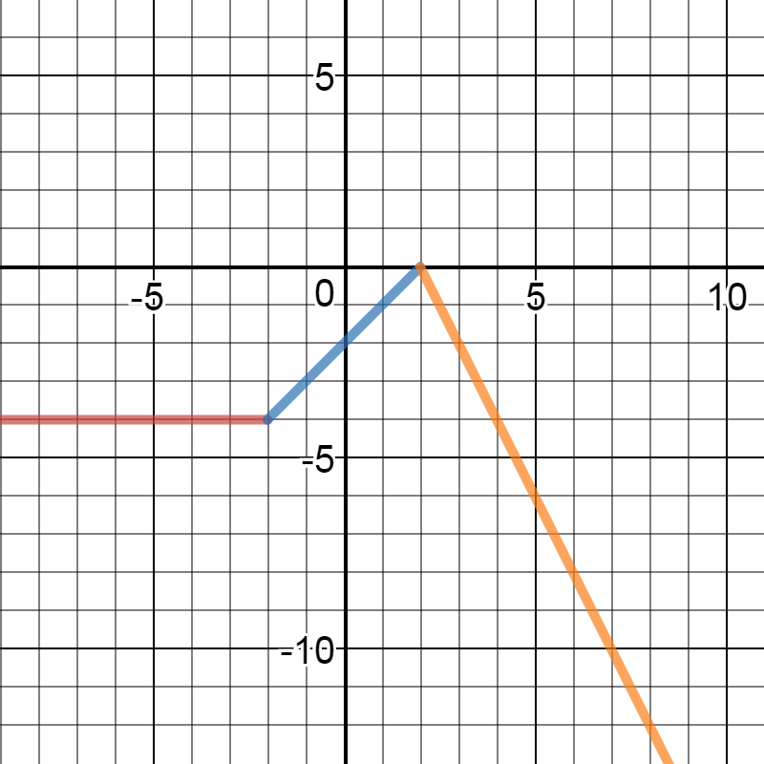 f.** 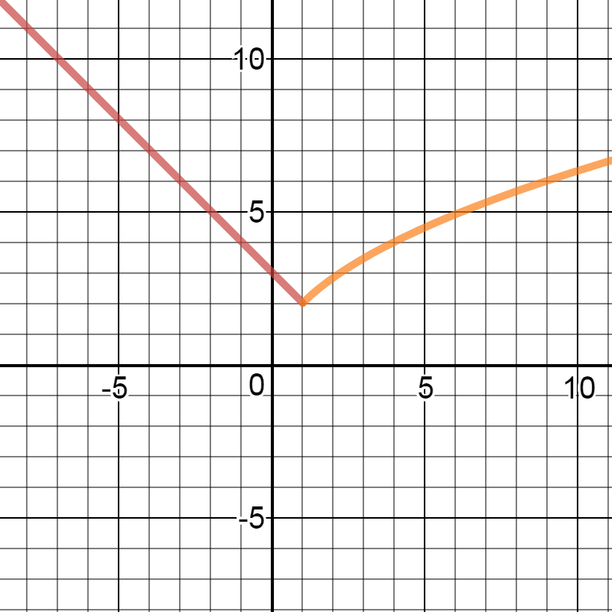

$f\left(3\right)=-7, f\left(-4\right)=1, f\left(-2\right)=3$

$f\left(-2\right)=-5, f\left(6\right)=13, f\left(1\right)=3$

$f\left(-4\right)=\frac{8}{3}, f\left(8\right)=30, f\left(2\right)=6$

$f\left(-2\right)=6, f\left(0\right)=4, f\left(5\right)=\frac{7}{3}$

$f\left(-3\right)=-4, f\left(-2\right)=-4, f\left(2\right)=0$

$f\left(0\right)=3, f\left(1\right)=0, f\left(4\right)=4$

$f\left(x\right)=\left\{\begin{aligned}x, &x≤0 \\ 2x, &x>0\end{aligned}\right.$ $f\left(x\right)=\left\{\begin{aligned}x+5, &x<-2 \\ -2, &x≥-2\end{aligned}\right.$ $f\left(x\right)=\left\{\begin{aligned}x+2, x≤1 \\ x+3, -1<x<1 \\ x+1, x≥1\end{aligned}\right.$

$f\left(x\right)=\left\{\begin{aligned}3x+10, &x≤-2 \\ 4, -2<&x<2 \\ -3x+10, x≥2\end{aligned}\right.$ $f\left(x\right)=\left\{\begin{aligned}1, 0≤x<2 \\ 3, 2≤x<4 \\ 5, 4≤x<6\end{aligned}\right.$