**Culture and Change (Lessons 3-7)**

**Cultural Adaptation: How Does Where People Live Affect How People Live?**

From earliest times people have found ways to adapt, modify, or use their natural environments. We adapt to our environment when we change our way of living to survive in a particular place. In Michigan, we adapt to the climate by building houses with heat and wearing warm coats in the winter. The ability of humans to adapt to almost any environment on Earth has enabled humanity to survive and flourish practically all over the world. The study of a culture’s interactions with its physical environment is called cultural ecology.

Where we live affects how we live. In the process of adapting to our environment, we change a variety of cultural components such as the type of houses we live in, the clothing we wear, and the food we eat. While technological advances have made it possible to get products from all over the world, the culture of a region tends to reflect its geography. In the United States, people living in earthquake-prone regions take precautions in building their homes to withstand such natural disasters. Similarly, people living in flood-prone regions of Asia put their homes on stilts.

Let’s take a look at the nomadic herders in Mongolia and explore how they have found many ways to adapt to its challenging geography.

Mongolia is about twice the size of Texas, or just a little larger than Alaska. The country is mountainous with an average altitude of 1,580 meters above sea level. The principal mountains are concentrated in the west, with much of this region having elevations above 2,000 meters, and the country's highest peaks permanently snow-capped land covered with glaciers.



Source: *Topographical Map of Mongolia*. 14 January 2013 <<http://www.photius.com/images/mn02_01a.jpg>>.

Mongolia is dry, as nearly 90% of the land is steppe, either pasture or desert. It includes part of the Gobi Desert which extends from China into southern Mongolia. This desert is mostly rock or gravel with only 5% sandy dunes. Only 1% of Mongolia’s land is arable, or suited for agriculture. There are limited natural fresh water resources in some areas.

Mongolia has a continental climate with severe variations in temperature between the seasons. Winter averages -40 degrees Fahrenheit while summer gets to 113 degrees Fahrenheit. Powerful winds are common in the country.

Natural hazards include dust storms, grassland and forest fires, drought, and ‘zud’, which refers to harsh winter conditions.

Mongolian pastoral herders make up one of the world’s last remaining nomadic cultures. For millennia they have lived on the steppes, grazing their livestock on the lush grasslands. Nomadic life is the way of life for about half of Mongolia’s population. There the country is one of the last in the world today with such a high proportion of nomadic citizens.

Because of the climate, lack of arable land, and a short growing season, animal husbandry defines the nomadic culture. People raise five types of animals: goats, sheep, cattle (including yaks), camels, and horses. These provide meat, dairy products, transportation, and wool. Families follow a seasonal routine, moving the herds to new grazing land based on the time of year.

As one of the only remaining horse-based cultures left in the world, Mongolians cherish their horses. Outside the capital, the horse is still the main mode of transportation and children begin riding as soon as they can sit up.

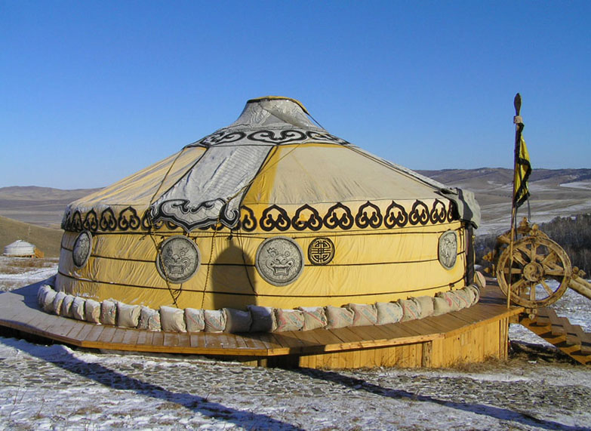

Because of Mongolia’s unique geography, people have to move with their herds, so it is important to have a house that is easy to take down and put up. Look at the structure in the photograph. It is called a ger. It is the type of home that Mongolian pastoral herders use. In fact, gers have been used for over a thousand years. The use of gers as a form of shelter is a cultural adaptation the Mongolian pastoral nomads have made.

Gers are portable dwellings made of wood lashed together with leather thongs and covered with felt. Gers are easy to erect and dismantle. They are wind resistant, have good ventilation, and are portable. The structure, furnishings, and the stove inside can be carried by just three camels or wagons pulled by yaks. Due to the lack of available firewood, gers are often heated by small metal stoves fueled with dried dung.

Cultural adaptation can also be seen in the foods that Mongolian nomads eat. Lacking fertile farm land, vegetable and fruits are not plentiful. As a result, people are dependent on animals for food, eating a variety of meat and dairy products. The traditional foods shown below include meat dumplings (A), meat pastries (B), cheese (C), airag (fermented mare’s milk, the national beverage) (D), and meat stew (E).

C

B

A

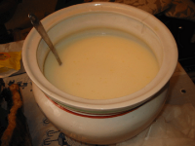

E

D

How Do People Shape the Environment Where They Live?

In addition to adapting to the environment, people also modify or shape where they live to meet their needs. When a natural landscape gets modified by humans, it becomes what is known as a cultural landscape. They include buildings, agricultural features, bridges, and thousands of other human features. Cultural landscapes can change over time and help us in understanding the history of a place.

**The environment shapes cultures.**

**Cultures**

**shape**

**the**

**environment**

**Cultural Adaptation**

**Cultural Landscapes**

Notice the different cultural landscapes below. What do they say about how people live?

|  |  |
| --- | --- |
| Houses in Mexico City | Solar Power Plant in Andalusia, Spain. |
| Hartsfield-Jackson International Airport, just outside of Atlanta. | Residential Development in Florida |
| Tokyo, Japan | Orange Orchards in Uruguay. |

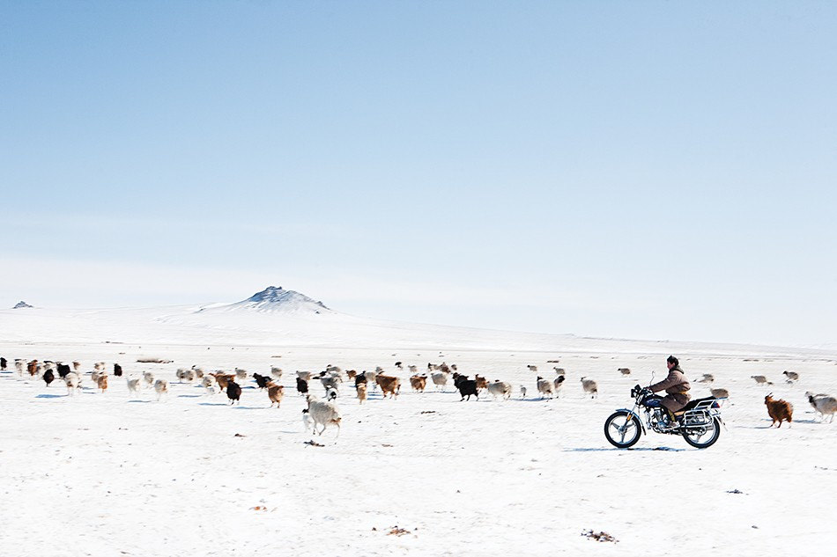**How and Why Do Cultures Change?**

****We have learned that where people live shapes how they live. The values, beliefs, behaviors, tools and other material objects people use are influenced by their physical environment. However, culture does not remain static. Shifts can occur within cultures as a result of either outside or inside influences. It might surprise you to know that the images to the right represent the nomadic culture of Mongolia. Herding animals with a motorcycle rather than a horse is something that never would have been seen in this culture 100 years ago. Eating pizza, clearly not a traditional Mongolian food, is a relatively new phenomenon as well. Clearly, this culture has undergone changes. Typically, cultures change in two ways, through local invention or through cultural diffusion.

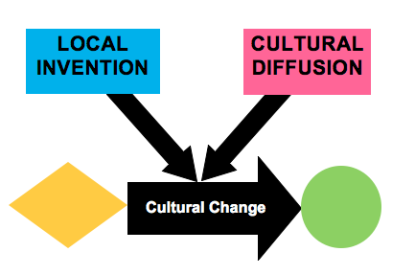

Local Invention

One of the ways cultures change is through ‘local invention’. An example of this is the social network, Facebook. This new cultural trait, invented by a student at Harvard University, has changed American culture forever. Other examples of local invention from American culture might include skateboarding or hip-hop music. Like American culture, the Mongolian nomadic culture has also experienced change. The ger is probably a local invention since it was created as a method for adapting to the challenging environment of Mongolia.

Cultural Diffusion

Besides local invention, cultures can also change through cultural diffusion. Cultural diffusion is the spread of ideas, beliefs, and goods from one place to another. When people from one culture interact with people from another, aspects of culture tend to spread from one place to another. The diagram below shows how FACEBOOK began as a local invention in the U.S. It was developed at Harvard University, expanded to a few universities, and, by 2006, had expanded to most American colleges and high schools. The new cultural trait of FACEBOOK did not remain solely within the American culture, however. As indicated in the diagram below, it expanded outside the U.S. between 2005 and 2006, and continued to spread as it was marketed to older users and translated into various languages. FACEBOOK was diffused, or spread, through technology. This diffusion has continued; by 2015, the number of worldwide users had reached 1.44 billion.

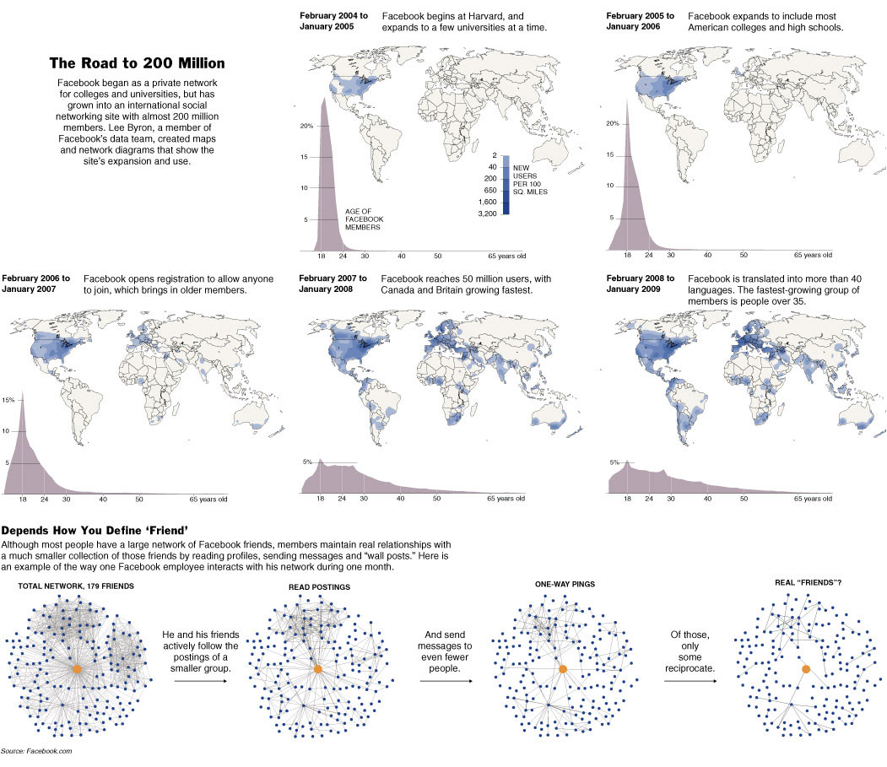

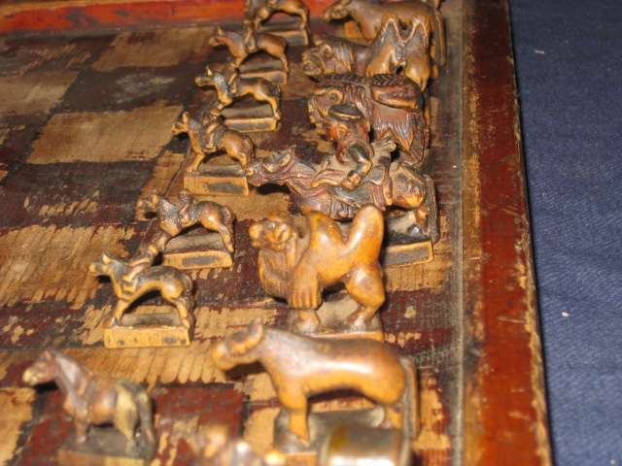The game of chess is a cultural trait in Mongolia. How could you determine whether chess was a local invention or an example of cultural diffusion? There would have to be evidence to show that someone in Mongolia invented the game or that someone from outside the county brought the idea to the Mongolian culture from somewhere else.

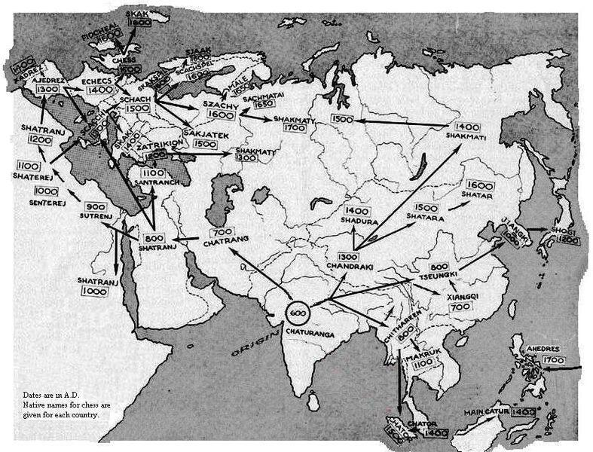

The origin of some cultural traits, like FACEBOOK, is sometimes very easy to determine because

their local invention took place relatively recently. However, it is more difficult to trace the origins of some cultural traits that originated long ago. The map on the right shows the origin of the game of chess to be somewhere in central India. This gives us evidence to support the idea that chess likely exists in Mongolia as a result of cultural diffusion.

Most historians identify seven to eight locations where many important cultural traits originated. Many of these areas were river valleys, where human civilizations first developed and flourished. In seventh grade, you will study several of these areas in depth. As cultural traits developed in these regions and people interacted with others from different places, these cultural traits were diffused and moved outward to new places.

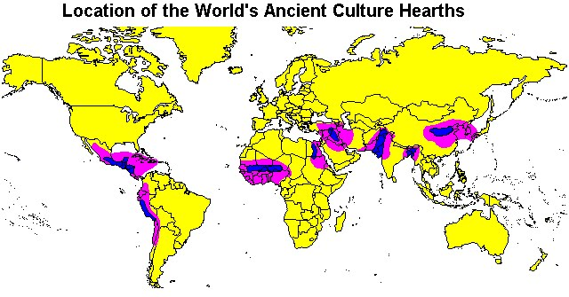

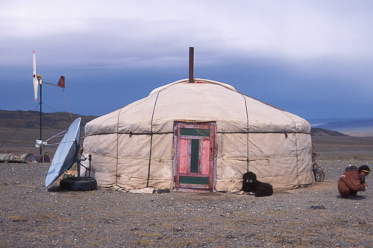Mongolian nomadic culture, like all cultures, has changed through cultural diffusion. The major causes of cultural diffusion have traditionally been migration, trade, and conflict. However, there is another major cause that is reflected in the photo on the right. Not only is the satellite dish a cultural trait developed through diffusion, it is also a reminder that technological improvements can spread cultural traits more quickly than ever across cultures. Just think about what can be learned about other cultures with modern communication and technology!

Culture is a powerful force in people’s lives. People greatly value their own cultural traits. So, why would people adopt a cultural trait from another culture? Perhaps people accept new cultural traits because the cultural trait, like a microwave oven, allows them to do work more efficiently. Perhaps the cultural trait is enjoyable, like salsa dancing. A cultural trait may be an improvement over what a culture is presently doing, like using a motorcycle instead of a horse or camel. Lastly, and maybe the most common reason to adopt a cultural trait, is that something simply is appealing to the senses. For example, many cultures have incorporated tacos and pasta into their diet because they taste good.

Barriers and Responses to Cultural Diffusion

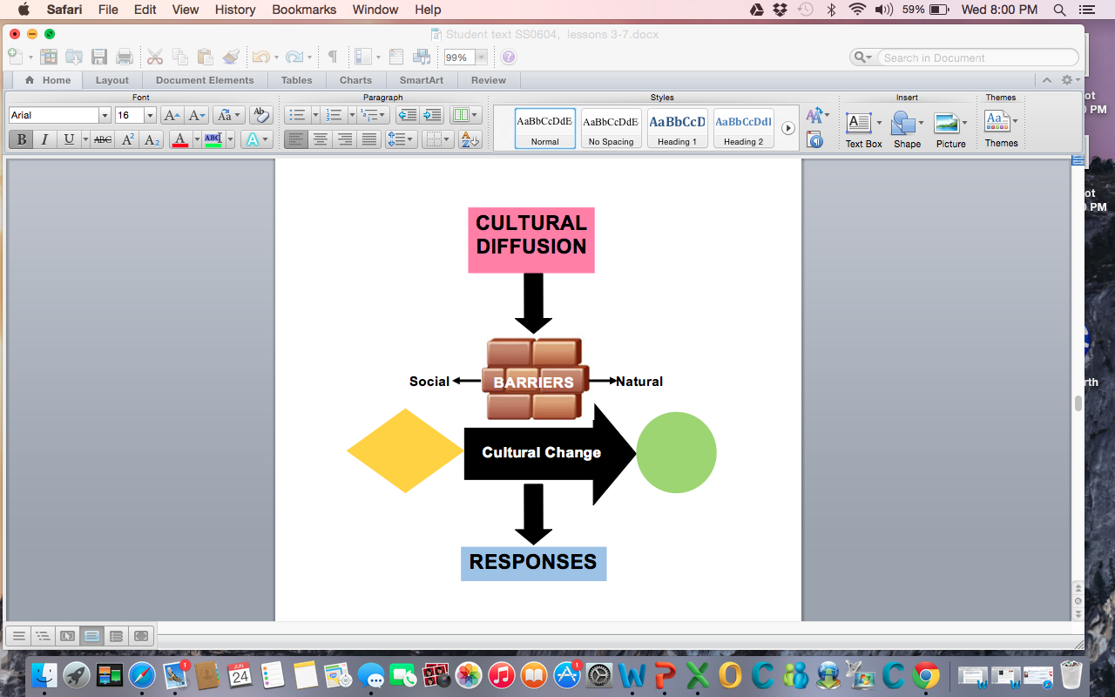

Cultural diffusion is a natural consequence in our global community. More people are traveling and migrating internationally, more countries are trading goods, men and women are fighting wars on foreign soil, country boundaries are re-drawn as a result of conflicts, and technological advances allow learning like never before. Technology and improved communication make it is easier than ever to learn about the cultural traits of others. Learning about how other people live is the first step to incorporating some of these traits into one’s own culture. However, cultural change is not always easy. In fact, there are two factors that might block the diffusion, or spread, of a cultural trait from one culture to another: physical characteristics and human characteristics.

**Physical Characteristics**

The map on the left shows the origination of four

world religions and how those religions spread over time.

Notice the similarities between the origination of these religions and the ancient cultural hearths identified on the map on page 6. North and South America are not shown

on this map because they were the last places these

religions appeared. Before there were planes, phones or

the Internet, it was difficult for ideas to pass to new areas

that were separated by large bodies of water. In this case, the Atlantic and Pacific Oceans are physical features that caused barriers to the cultural diffusion of these religions. Other physical features that inhibit cultural diffusion might include deserts, mountains, rain forests, and swamps. Over time, technological improvements in transportation and communication have lessened the impact of physical features as barriers to cultural diffusion.

**Human Characteristics**

Human or social characteristics can also serve as barriers to cultural diffusion. Sometimes people might be afraid of change, be opposed a change for religious reasons or they may simply not want to give up what they are presently doing.

In this photograph, a group of students in Pakistan are protesting the diffusion of Facebook. They were upset because of a controversial page that encouraged users to submit images of Islam's Prophet Muhammad. Because the Islamic religion prohibits the depiction of the Prophet Muhammad, protests occurred in Pakistan and other Muslim countries. In this case, religion is the human barrier to cultural diffusion. Other human characteristics that may act as social barriers might include language or a history of conflict.

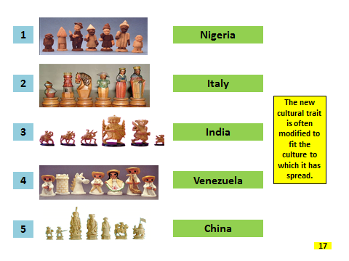**Responses to Diffusion**

Often, cultures adapt new ideas or objects to fit their own culture. This important idea about cultural diffusion is reflected in the different chess sets on the right. Although the game of chess has diffused throughout the world, the game pieces themselves have been modified to reflect each unique culture.

Often new cultural traits are diffused into a culture through big corporations. The McDonald’s in the photographs below is in India. When McDonald’s expanded here, the company could not sell the same hamburgers eaten in the United States because many Indians are vegetarians. In addition, in Hinduism the cow is a protected animal, and followers of this religion do not eat beef. As a result, McDonald’s altered their ingredients in order to sell their food in India. This is another example of making modifications to a cultural trait as it diffused into a new culture.

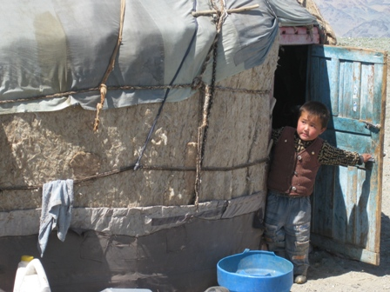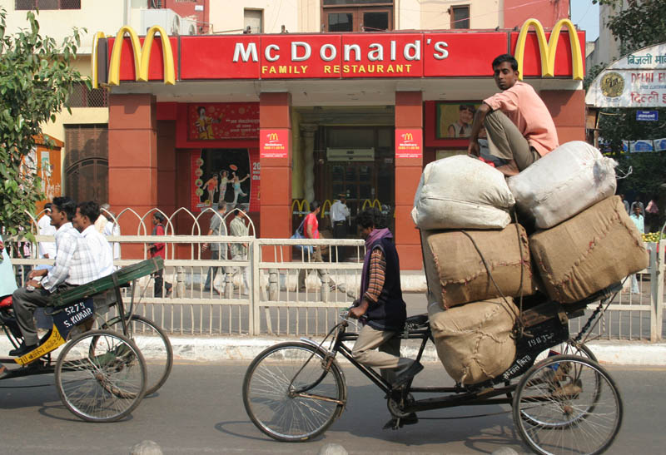

Look at the photograph on the right. What cultural trait appears to have diffused into Mongolia? The boy is wearing blue jeans. Blue jeans were a local invention of the western United States, and today we see this cultural trait has been diffused all the way to Mongolia. The chart below details the progress of the cultural diffusion of jeans in the world. Over time, social or human barriers were eliminated, and blue jeans spread from being a cultural trait of just the low-income workers of a very specific area to one that is shared by people in every social class and continent.

|  |  |  |
| --- | --- | --- |
|  | **Late 1800s** | ***Jeans were invented for farm and mine workers in the western states of the United States.*** |
| **From the late 1800’s to World War II** | ***World War II Jeans were worn only in the western states of the U.S. Some wealthy people living in the eastern part of the U.S. began to wear jeans at dude ranches on visits to the western states.*** |
| **During World War II** | ***American soldiers from western states who were stationed in Europe and Japan wore jeans. As a result, Europeans became interested in them.*** |
| **1950s** | ***People began to wear jeans as casual wear after some movie stars wore them both in movies and in real life.*** |
| **1960s** | ***Jeans spread to the American middle class.*** |
| **Now** | ***Jeans are commonly worn throughout the world.*** |

The Role of Fads in Cultural Change

****Sometimes, an activity, style, object, or idea can quickly become very popular. We have seen this recently in American culture with the wearing of silly bandz or yoga pants, shopping at cupcake specialty stores, or playing Angry Birds. If a new trend becomes permanently embedded in a culture, it simply becomes a new cultural trait. However, if the idea is only a short-lived enthusiasm, it is referred to as a fad. By its very definition, a fad does not bring about permanent cultural change. Fads are often related to cultural traits such as food, hairstyle, clothing, and toys, and they often begin in schools or through the media. They can be the result of local invention (flash mobs) or cultural diffusion (Pokemon Cards). Below are some fads from the past that may be familiar to you.

|  |  |  |  |  |
| --- | --- | --- | --- | --- |
| **Fad** | **Description** | **When?** | **Why?** |  |
| **Beehive Hair** | A hairstyle created by Chicago stylist Margaret Vinci Heldt.  It put all the hair on top of the head in a style of a hat and looked like a beehive made out of hair.  It was a style that maintained its shape. | **1960** | Women were already in love with the big hair trend, thanks to the bouffant, and the longer-lasting beehive was a timesaver. Women could sleep with their hive in a scarf, smooth away the loose strands in the morning, and be ready to go. | **http://t1.gstatic.com/images?q=tbn:ANd9GcS7QwRuhWkR8206lFx8ya-PTTjy9Pixdho_0F5r6AVtdtNCb6sHf3ctAjjs** |
| **Flagpole sitting** | It began when a friend dared actor Alvin “Shipwreck” Kelly to sit on a flagpole. Kelly took on the dare and sat on a flagpole for 13 hours and 13 minutes.  The odd spectacle set off a series of imitators who sought fame and money and a chance to beat Kelly’s record.  By 1930, the flagpole sitting craze faded into history. | **1924** | People did not have television or radio and were looking for a way to entertain themselves outside of the home.  By 1930, the flagpole sitting craze faded into history. | **Description: http://static.neatorama.com/images/2007-01/flagpole-sitting.jpg** |
| **Goldfish Swallowing** | People started swallowing goldfish to set records on how many a person could swallow.  The craze slowed down after many schools threatened to expel the fish eaters, but the stunt managed to remain popular enough to ensnare the next generation.  The current world record, 300 fish in one sitting, was set in 1974. | **1939** | It started as a competition and a bet in college and spread. | http://www.mortaljourney.com/main/wp-content/uploads/ManSwallowingGoldfish.jpg |
| **Phone Booth Stuffing** | College kids tried to get as many people together to see how many they could get to fit into a phone booth.  The door could be left open as long as half of the person was in the booth. | **1959**  **Began in South Africa** | It developed out of a competition first started in South Africa, and then spread to London and the United States.  This fad began to expire the same year when studying for May and June finals meant that students had to concentrate on other things. | **Description: http://static.neatorama.com/images/2007-01/telephone-booth-stuffing.jpg** |
| **Poodle Skirts** | A nonrestrictive clothing style that allowed girls to move more freely to the music.  It was a colorful, full, swingy skirt that typically hit just below the knee. It was commonly made of felt fabric and appliquéd with an image of a poodle, hence the name. Sometimes other images of the era, like 45 rpm records, dice, and musical notes, also appeared on the skirts. They were easily constructed following a simple pattern. | **1950s** | They allowed girls to move more easily while dancing.  They were easily constructed following a simple pattern. | **http://2.bp.blogspot.com/-FRFicE_DW9k/TdWcI8salQI/AAAAAAAAADI/zL3OfHz3g84/s1600/3969366635_bf27266322.jpg** |
| **Drive-In Theaters** | It put cars and movies together. People watched movies in their cars. They used the new FM technology to send a movie's sound directly into a viewers' car radio. | **First opened in 1933**  **Caught on in the early 1950s** | Technology made this possible by piping sound through the car radio.  Drive ins appealed to groups of teenagers, families and couples wanting some privacy while watching a movie. It was an inexpensive option to watching movies and often had playgrounds for children. | **http://4.bp.blogspot.com/-tiMNOAU_RxU/TzpkzxhwolI/AAAAAAAADLE/CjSNODZ9CkY/s1600/garten_drive-in_theatre_circa_1954%255B1%255D%2B%25282%2529.jpg** |