**H. Geometry - Bellwork #7 February 7th, 2019**

**Find the values for which the figure is a parallelogram.**

1.   2.  

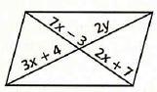 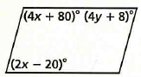

**State whether each quadrilateral is a parallelogram. You do not need to explain.**

3. 4. 5.

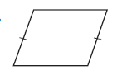 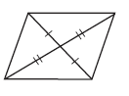 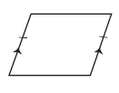

**Classify each quadrilateral by its most precise name.**

6. ________________________ 7. ­­­­­­­­­­­­­________________________

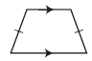 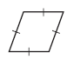

8. ________________________ 9. ________________________

 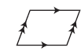

**Answer each question below with *true* or *false*.**

10. All squares are rhombuses. ____________

11. All rectangles are squares. ____________

12. An isosceles trapezoid is a parallelogram. ____________

13. A kite has one pair of parallel sides. ____________

14. A trapezoid has exactly one pair of parallel sides. ____________

15. A parallelogram has 2 pairs of parallel sides. ____________

**There is a back ☺**

**Fill in the blank with the appropriate word.**

16. A ____________________ is a rectangle, rhombus, and parallelogram.

17. A ____________________ has two pairs of adjacent, congruent sides and no parallel sides.

18. A rectangle has four _________ angles.

19. A rhombus is a parallelogram with four congruent ___________.

20. Find x and y in the parallelogram below.

