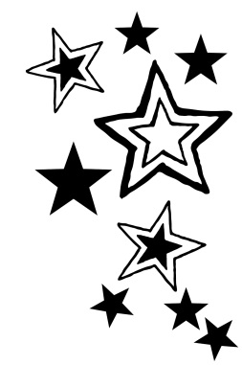
FANTASTIC FLYERS
Students at Lindbergh Elementary practice the 7 Habits of Highly Effective People. We are calling on our Fantastic Flyers to submit ways they are leaders outside of school. If you are involved in a sport, scouts, music, dance, theater, or showcase your leadership skills in another way, please participate. Send in a photograph and a short description of how you use the 7 Habits in the activity pictured. Use the form below to accompany your photo. The photograph will appear in the lobby showcase.
Thank you for sharing your leadership with our school!
Name:____________________________________________________________________________
Grade:____________________ Classroom Teacher:_____________________________________
____________________________________________________________________________________________________________________________________________________________________________________________________________________________________________________________________

__________________________________________________________________________________________________________________________________________________________________________

