Section 9.2 - 9.3 Guided Notes

Factor.

1. ______________________

2. ______________________

3. ______________________

Expand: ______________________

Using the foil method.

Expand: ______________________

Using the distributive property.

Expand: ______________________

Using the box method.

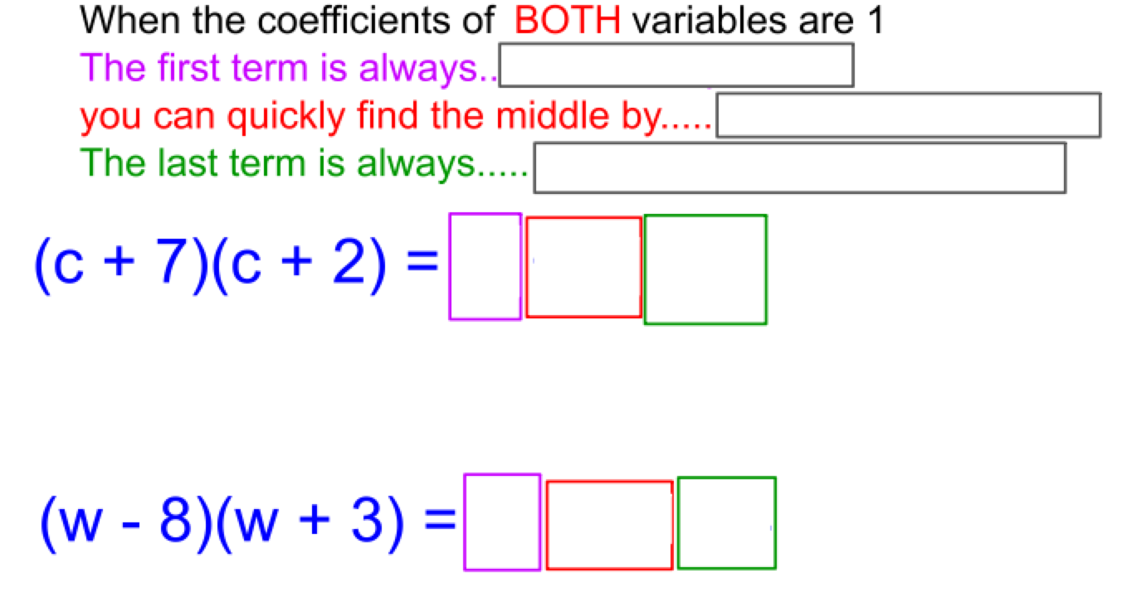
Expand each. Write answers in Standard Form.

1. 2.

3. 4.

5. 6.

Expand.

1.

2.

3.

