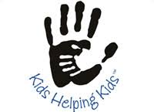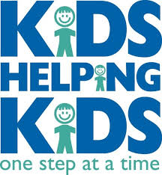

Who: Whitmore Bolles Students
What: pay $1 to wear PJ’s to school
Why: Helping Hurricane Irma’s student victims
When: Wednesday October 18

